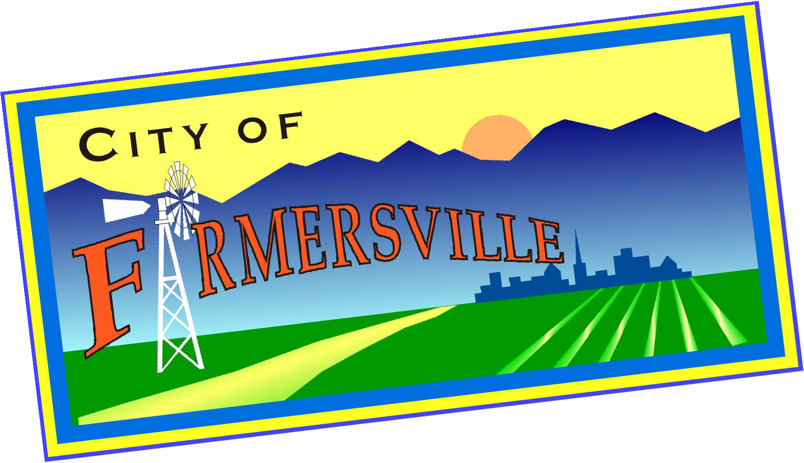Downtown Farmersville Specific Plan
Progress Update

In 2021 the City of Farmersville began preparing a specific plan for the improvement of downtown area. The purpose of the Specific Plan is to establish a series of goals and action plans to revitalize the heart of our community.

Specifically, the Downtown Farmersville Specific Plan is intended to assist in transforming downtown Farmersville into an exciting and thriving pedestrian-oriented shopping, dining, residential and entertainment district for Farmersville.

What Areas Are Included?

The area subject to the Downtown Specific Plan includes the Farmersville Boulevard corridor, extending from Visalia Road on the south to the San Joaquin Valley Railroad on the north, including private properties bordering the east and west side of the street, along with alleys that parallel Farmersville Boulevard (see map to the right).

Public Survey Results

The City has an online survey available on the City of Farmersville website asking the public for their thoughts on the downtown. So far over 100 persons have taken the survey. The survey is intended to help the Plan reflect the public’s thoughts and ideas about downtown Farmersville. A few findings from the survey are as follows:

Question: What Do You Like Most About Downtown?

- Small town character
- Restaurants
- Local stores and shops
April 2022

Downtown Specific Plan Area
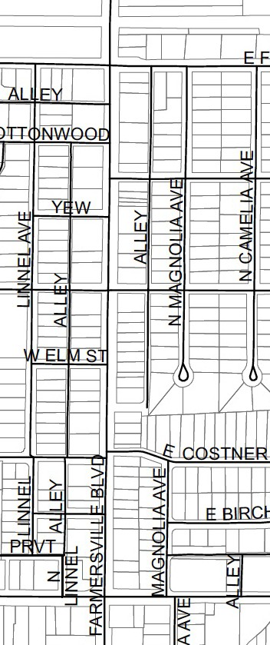
Railroad
FRONT ST.
PEPPER ST.
VISALIA
ROAD
north

Downtown Farmersville Specific Plan Newsletter
March 2022

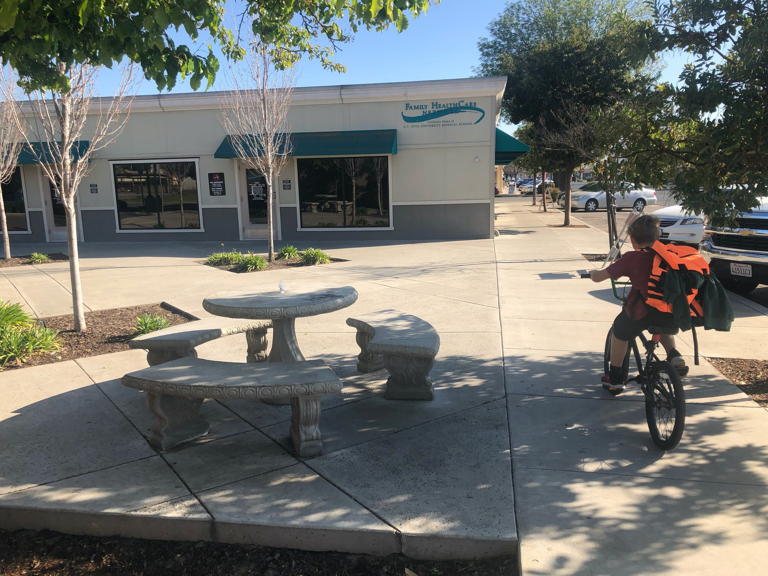Question: What Are the Key Issues that Downtown is Facing?

- Cleanliness
- Safety
- Crime
- Not enough light at night

Question: What Elements Do You Think Would Make Downtown More Successful?

- Varied choice of uses and experiences – retail, restaurants, entertainment, civic, service or non-profits
- Pedestrian and bicycle friendly environment – comfortable, walkable, shaded, lighting
- More shade trees and landscaping
- Outdoor seating and dining

Question: Currently there are many things to build on in downtown. What top three are most exciting to you?

- Bringing more users and momentum into Downtown (e.g. More stores and restaurants, offices and entertainment uses)
- An opportunity to redesign Farmersville Boulevard (the current roadway is very wide) - widen sidewalks, add bike lane, trees, shade landscaping, seating, etc.)
- Construction of housing in the downtown (which will bring more people to the area).

What’s Next

The City is currently working with the Farmersville Planning Commission in a series of workshops to generate ideas for the Specific Plan. These workshops are open to the public and participation is invited! If you have ideas for the downtown area, feel free to email them to the City’s consultant Karl Schoettler at karl@weplancities.com. All ideas are welcome!

We Want to Hear From You!

For more information or to be placed on an email notification list about events and workshops on the Downtown Specific Plan, please contact the Farmersville City Clerk (Rochelle Giovani) at RGiovani@cityoffarmersville-ca.gov or at 559 747-0458.

